WELCOME BACK TO OUR OFFICE!

To keep our patients and employees safe during the COVID-19 pandemic, we are following safety guidelines from the Centers for Disease Control and Prevention. Here’s what to expect when you visit the office.

WHAT WE WILL DO
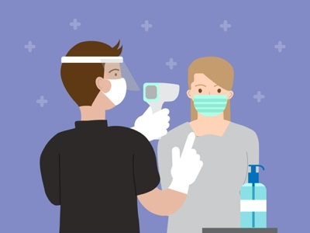
- Screen all patients, doctors, and staff members for COVID-19. Screening includes checking temperatures of everyone who enters our office.
- Require employees to wear personal protective equipment.
- Provide hand sanitizer and disinfectant in exam rooms, waiting rooms, bathrooms, and other common areas.
- Disinfect exam rooms and common areas.
- Limit daily office appointments to reduce contact and exposure.

WHAT YOU CAN DO
- If you have a fever or other COVID-19 symptoms, call the office to discuss the best option for seeking medical care.
- Wear a face covering as soon as you enter the office.
- Use hand sanitizer when you enter the office.
- Come alone, unless having a caregiver is medically necessary.
- Ensure any minor child arrives with a parent or guardian.
- Complete and sign all necessary documents before your appointment.
- Maintain social distancing in the office.

TELEHEALTH UPDATE
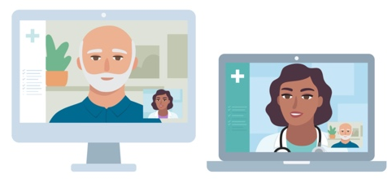
We will still offer telehealth appointments. You may ask for a telehealth visit if you do not need a physical exam or in-person treatment. Please confirm with your health insurance carrier that they cover telehealth visits.

We care deeply for the health of our patients, employees, and community. We look forward to seeing you!

